
Semester | T.E. Semester VI– SPCC
Subject | Software Engineering
Subject Professor In-charge | Prof. Pankaj Vanvari
Assisting Teachers | Prof. Pankaj Vanvari
Laboratory | M310B

Student Name | Deep Salunkhe
Roll Number | 21102A0014
TE Division | A

Title:
Macro pre-processor
Approach:

- Input File Reading (readfile function):
  - The readfile function reads the contents of a given file (fileName) character by character and separates them into words based on spaces and newline characters.
  - It stores the words in a vector called input, representing the input file's content.
- Pass 1 (pass1 function):
  - Pass 1 of the assembler involves scanning the input file and building necessary data structures like Macro Name Table (MNT), Macro Definition Table (MDT), Formal Parameter List (FPL), and Argument Parameter List (APL).
  - The function scans through the input vector and identifies macro definitions (MACRO and MEND directives).
  - For each macro definition, it extracts macro name, positional parameters, and the macro body, then stores this information in respective data structures (MNT, MDT, FPL).
  - The MNT maps macro names to their respective positions in the MDT.
  - The MDT stores the lines of the macro definition.
  - The FPL maps macro names to their respective formal parameter lists.
  - The APL, though not used in Pass 1, could be used in Pass 2 to handle actual arguments of macro calls.
- Macro Expansion (Expand function):
  - The Expand function performs macro expansion using the data structures built in Pass 1.
  - It iterates through the input vector, identifies macro calls by checking the MNT, and expands them by substituting actual arguments for formal parameters.
  - The expanded code is written to an output file named "macroexpanded.txt".
- Challenges
- The most challenging part for me was the implementing the APL and FPL part not because it is difficult to implement , but because when we learning this in this part in the class I don’t know why I thought that APL and FPL data bases were not adding anything extra to this architecture , so I started to implement it with that mind set, and it took me hours to understand that I was very wrong

Implementation:

#include <iostream>
#include <fstream>
#include <vector>
#include <string>
#include <map>
using namespace std;

int readfile(string &fileName,vector<string> &input){
char ch;
fstream fp;
fp.open(fileName.c_str(), std::fstream::in);

if (!fp)
{
cerr << "Error opening the file: " << fileName << endl;
return 1; // Return an error code
}

string word;
while (fp >> noskipws >> ch)
{
if (ch == '\n')
{
input.push_back(word);
input.push_back(";");
word = "";
}
else if (ch == ' ')
{
input.push_back(word);
word = "";
}
else
{
word += ch;
}
}

input.push_back(word);

fp.close();
return 0; // Return success code

}

void print_vector(vector<string> &input)
{
for (int i = 0; i < input.size(); i++)
{
cout << input[i] <<endl;
}
cout << endl;
}

void pass1( map<string,int>&MNT_MDTP,map<string,int>&MNT_PP,vector<string>&MDT, map<string,vector<string> >&FPL,map<string,vector<string> >&APL,vector<string>input,vector<string>&input_copy){

//start going throught the inptus
int inputsize=input.size();
for(int i=0;i<inputsize;i++){

if(input[i]==";") continue;

if(input[i]=="MACRO"){

//filling the MNT
i++;
i++;
int MDTnextindex=MDT.size();
string line1="";
string Macro_Name=input[i];
line1=line1+Macro_Name+" ";
MNT_MDTP[Macro_Name]=MDTnextindex;
//counting number of positional parameter
int ppc=0;
i++;
while(input[i]!=";"){
int currindex=FPL[Macro_Name].size();
//convertt it to string
string temp=to_string(currindex);

line1=line1+temp+" ";
//adding it to FPL and APL
FPL[Macro_Name].push_back(input[i]);

ppc++;
i++;
}
MNT_PP[Macro_Name]=ppc;

MDT.push_back(line1);

string line="";
i++;

while(input[i]!="MEND"){

if(input[i]==";"){
i++;
MDT.push_back(line+";");
line="";
continue;
}
//replacing the positional parameter
if(input[i][0]=='&'){
//find index[i] in the FPL[Macro_Name]

//cout<<input[i]<<endl;
int size=FPL[Macro_Name].size();
for(int j=0;j<size;j++){
//cout<<to_string(j)<<"test"<<endl;
//cout<<input[i]<<endl;
if(FPL[Macro_Name][j]==input[i]){
//cout<<to_string(j)<<"test"<<endl;
line=line+"#"+to_string(j)+" ";
break;
}
}

}else{
line=line+input[i]+" ";

}

i++;

}
MDT.push_back(input[i]);

}
}

}

void Map_print(map<string, int> &m)
{

for (std::map<std::string, int>::iterator it = m.begin(); it != m.end(); ++it)
{
std::cout << it->first << " " << it->second << std::endl;
}
}

void Map_print2(map<string, vector<string>> &m)
{
for (auto it = m.begin(); it != m.end(); ++it)
{
std::cout << it->first << ": ";
for (const auto &value : it->second)
{
std::cout << value << " ";
}
std::cout << std::endl;
}
}

void Expand(map<string, int> &MNT_MDTP, map<string, int> &MNT_PP, vector<string> &MDT, map<string, vector<string>> &FPL, vector<string> input, vector<string> &input_copy) {
cout << "Ready to expand" << endl;
vector<string> output;
int inputsize = input.size();

// Open the output file for writing
ofstream outputFile("macroexpanded.txt");
if (!outputFile.is_open()) {
cerr << "Error: Unable to open file for writing." << endl;
return;
}

for (int i = 0; i < inputsize; i++) {
if (input[i] == ";") {
outputFile << endl;
continue;
};
if (input[i] == "MACRO") {
//skip the macro
while (input[i] != "MEND") {
i++;
}
continue;
}

//if macro call is found
if (MNT_MDTP.find(input[i]) != MNT_MDTP.end()) {
string Macro_Name = input[i];
map<int, string> APL;
int MDTindex = MNT_MDTP[input[i]];
MDTindex++;

i++;
int ind = 0;
while (input[i] != ";") {
APL[ind] = input[i];
i++;
ind++;
if(i >= inputsize) break;
}
// cout << "The macro name is " << Macro_Name << MDTindex<<endl;

//creating the output
while (MDT[MDTindex] != "MEND") {
string line = MDT[MDTindex];
int size = line.size();
string temp = "";
for (int i = 0; i < size; i++) {
if (line[i] == ' ' || line[i] == ';') {
outputFile << temp << " ";
if (line[i] == ';') outputFile << endl;
temp = "";
continue;
}

if (line[i] == '#') {
i++;
int ind = line[i] - '0';
outputFile << APL[ind] << " ";
continue;
}

temp += line[i];
}
MDTindex++;
}
}
}

// Close the output file
outputFile.close();

cout << "The macro expansion is done." << endl;
}

int main(){

//macro name table structure
map<string,int>MNT_MDTP;
map<string,int>MNT_PP;
vector<string>input_copy;

//FPL and APL
map<string,vector<string> >FPL,APL;

//macro defination table
vector<string>MDT;

//input file
vector<string>input;

//files to read and save;
string readfrom;
string saveas;

cout<<" Enter file name to read"<<endl;
cin>>readfrom;
if(readfile(readfrom,input)==0){

//cout<<"The inputfile is"<<endl;
//print_vector(input);
//filling the datasets
pass1(MNT_MDTP,MNT_PP,MDT,FPL,APL,input,input_copy);

cout<<"The MNT is"<<endl;
Map_print(MNT_MDTP);
Map_print(MNT_PP);

cout<<"The MDT is"<<endl;
print_vector(MDT);

// int temp=MDT.size();
// cout<<temp<<endl;

cout<<"The FPL and APL is"<<endl;
Map_print2(FPL);

// cout<<"The input_copy is"<<endl;
// print_vector(input_copy);

//cout<<"The APL is"<<endl;
//Map_print2(APL);

// pass2(MNT_MDTP,MNT_PP,MDT,FPL,APL,input, input_copy);
Expand(MNT_MDTP,MNT_PP,MDT,FPL,input, input_copy);

}

return 0;
}

End Result:

Input file:
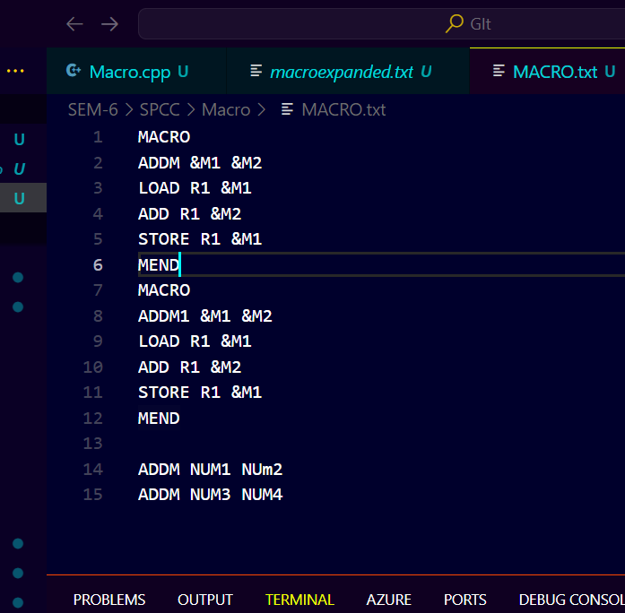

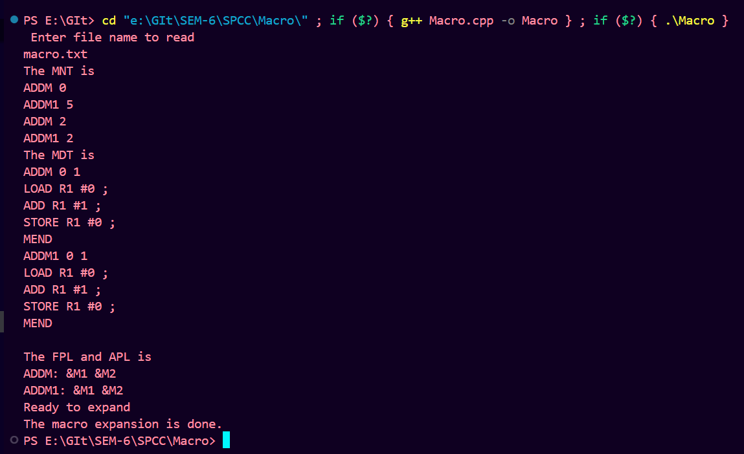

Output file
